**Digital Filter Specifications and Design**

**ID 201424020118**

**Name: - Abebe Hildana Getaneh**

**December, 2014**



|  |
| --- |
| UNIVERSITY OF ELECTRONIC SCIENCE AND TECHNOLOGY OF CHINA |
| Digital Filter Specification and Design Report Paper |
| Course:- Digital Signal Processing |
|  |
| **Abebe Hildana Getaneh (ID: 201424020118) Electonic Engineering School** |
| **12/15/2014** |

|  |
| --- |
| *Abstract: In this paper, specifications of digital filters and how to design digital filters based on those specification is discussed. First we find out the types of the specifications and then discussed types of designing tools and at last compared the tools.* |

Contents

1. INTRODUCTION 3

2. Digital Filter Specifications 3

Figure 1. types of ideal filters 4

Figure 2. Magnitude response of a digital lowpass filter 4

Figure 3. Normalized form of Magnitude response of a digital lowpass filter 5

Figure 4. Highpass filter 6

Figure 6. Bandstop filter 7

3. Digital Filter Designing 7

3.1. Finite Impulse Response (FIR) Filter 7

3.1.1. Ideal filter approximation 7

Table 1. The frequency responses of four standard ideal filters 8

3.1.2. FIR filter design using window functions 8

3.1.2.1. Rectangular Window 9

Figure 7. Rectangular window in the time domain 9

Figure 8. Illustrates the frequency domain of rectangular window 9

3.1.2.2. Triangular (Bartlett) window 9

Figure 10. Triangular (Bartlett) window in the frequency domain (spectrum) 10

Figure 9. Triangular window coefficients in the time-domain 10

3.1.2.3. Hann Window 10

Figure 11. The Hann window coefficients in the time domain 11

Figure 12. The Hann window coefficients in the frequency domain 11

3.1.2.4. Hamming Window 11

Figure 13. The Hamming window coefficients in the time domain 12

Figure 14. The Hamming window coefficients in the frequency domain 12

3.1.2.5. Blackman Window 12

Figure 15. The Blackman window coefficients in the time domain 13

Figure 16. The Blackman window coefficients in the frequency domain 13

3.2. Infinite Impulse Response (IIR) Filters 13

3.2.1. Reference Analog Prototype Filter 14

Figure 17. S plane and region of stability 15

3.2.1.1. Butterworth analog filter 15

Figure 19. IIR filter specification 16

Figure 20. Position of Butterworth filter poles for N=5 and N=6 17

3.2.1.2. Chebyshev Analog Filter 18

Figure 21. Frequency response of Chebyshev analog filter 18

3.2.1.3. Inverse Chebyshev Analog Filter 20

Figure 22. Frequency characteristic of inverse Chebyshev analog filter 20

Table 2. coefficient k in the transfer function numerator 22

4. Conclusion 24

REFERENCES 25

# INTRODUCTION

Digital filters can be more subtly specified than analogue filters, and so are specified in a different way:

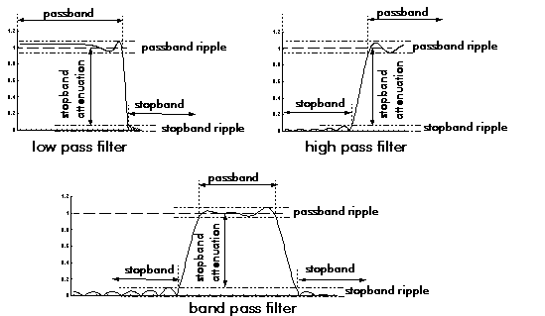

Digital filters are specified in terms of desired attenuation, and permitted deviations from the desired value in their [frequency response](http://www.bores.com/courses/intro/freq/3_spect.htm):

* Passband: - the band of [frequency components](http://www.bores.com/courses/intro/freq/3_ft.htm) that are allowed to pass.
* Stopband: - the band of frequency components that are suppressed.
* Passband ripple: - the maximum amount by which attenuation in the passband may deviate from nominal gain.
* Stopband attenuation: - the minimum amount by which frequency components in the stopband are attenuated.

# Digital Filter Specifications

Usually, either the magnitude and/or the phase (delay) response is specified for the design of digital filter for most applications. In some situations, the unit sample response or the step response may be specified. In most practical applications, the problem of interest is the development of a realizable approximation to a given magnitude response specification.

There are four basic types of ideal filters with magnitude responses as shown below

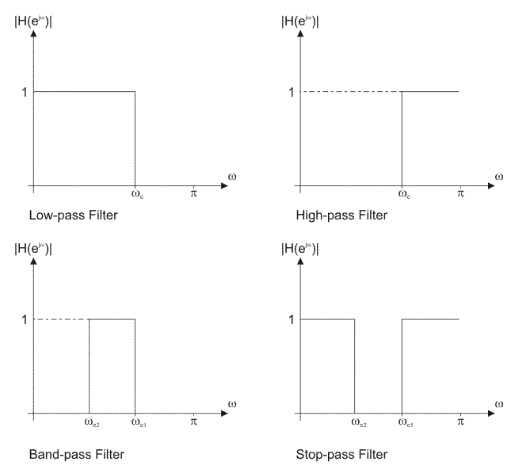

##### Figure 1. Types of ideal filters

As the impulse response corresponding to each of these ideal filters is non causal and of infinite length, these filters are not realizable. In practice, the magnitude response specifications of a digital filter in the passband and in the stopband are given with some acceptable tolerances. In addition, a transition band is specified between the passband and stopband.

For example, the magnitude response |G(ejω) of a digital lowpass filter may be given as indicated below

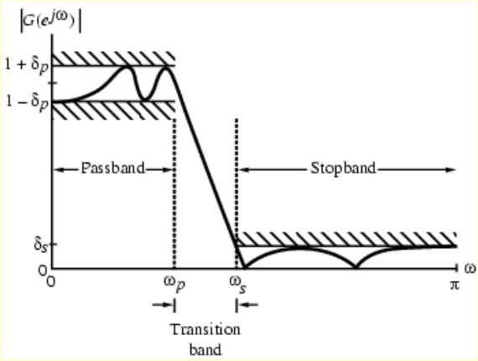

##### Figure 2. Magnitude response of a digital lowpass filter

As indicated in the figure, in the passband defined by, 0 <= ω <=ωp we require that |G(ejω)| = ˜1 with an error  , i.e.



In the stopband, defined by ωs <= ω <= π we require that |G(ejω)|=˜ 0 with an error , i.e.,



Where:-

* - passband edge frequency
* - stopband edge frequency
* - peak ripple value in the passband
* - peak ripple valuein the stopband

Since G(ejω) is a periodic function of ω, and |G(ejω)| of a real-coefficient digital filter is an even function of ω, As a result, filter specifications are given only for the frequency range

0 <= |ω| <=π.

Specifications are often given in terms of loss function  in dB.

Minimum stopband attenuation:-  dB.

Magnitude specifications may alternately be given in a normalized form as indicated below

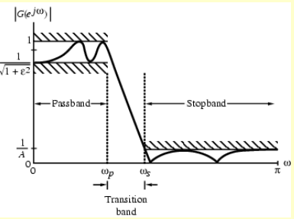

##### Figure 3. Normalized form of Magnitude response of a digital lowpass filter

Here, the maximum value of the magnitude in the passband is assumed to be unity.

* - Maximum passband deviation, given by the minimum value of the magnitude in the passband.
* 1/A- Maximum stopband magnitude.

For the normalized specification, maximum value of the gain function or the minimum value of the loss function is0 dB

* Maximum passband attenuation- dB.
* For бp << 1, it can be shown that  dB.

In practice, passband edge frequency Fp and stopband edge frequency Fs are specified in Hz.

For digital filter design, normalized bandedge frequencies need to be computed from specifications in Hz using,

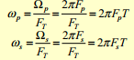

The following figure illustrates the magnitude frequency responses of a highpass filter, which passes high frequencies and attenuates low frequencies.

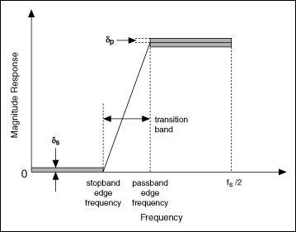

##### Figure 4. Highpass filter

The following figure illustrates the magnitude frequency responses of a bandpass filter, which passes a certain band of frequencies and attenuates lower and higher frequencies.

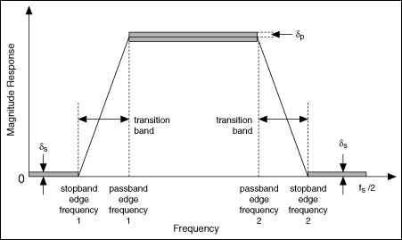

Figure 5. Bandpass filter

The following figure illustrates the magnitude frequency response of a bandstop filter, which attenuates a certain band of frequencies and passes all frequencies not within the band.

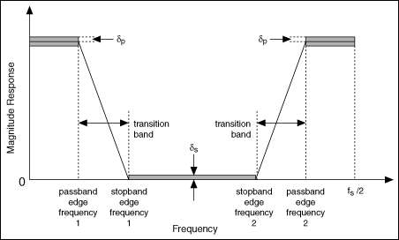

##### Figure 6. Bandstop filter

# Digital Filter Designing

## Finite Impulse Response (FIR) Filter

### Ideal filter approximation

The ideal filter frequency response is used when designing FIR filters using window functions. The objective is to compute the ideal filter samples. FIR filters have finite impulse response, which means the ideal filter frequency sampling must be performed in a finite number of points. As the ideal filter frequency response is infinite, it is easy to produce sampling errors. The error is less as the filter order increases.

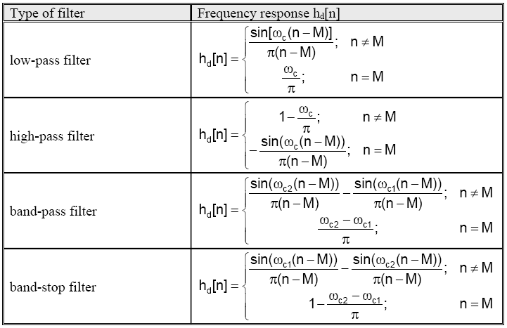

##### Table 1. The frequency responses of four standard ideal filters

### FIR filter design using window functions

The FIR filter design process via window functions can be split into several steps:

1. Defining filter specifications;
2. Specifying a window function according to the filter specifications;
3. Computing the filter order required for a given set of specifications;
4. Computing the window function coefficients;
5. Computing the ideal filter coefficients according to the filter order;
6. Computing FIR filter coefficients according to the obtained window function and ideal filter coefficients;
7. If the resulting filter has too wide or too narrow transition region, it is necessary to change the filter order by increasing or decreasing it according to needs, and after that steps 4, 5 and 6 are iterated as many times as needed.

The window method is most commonly used method for designing FIR filters. The simplicity of design process makes this method very popular.

#### Rectangular Window

The rectangular window is rarely used for its low stopband attenuation. The first lobe (refer to Figure 2-3-2) has attenuation of 13dB and the narrowest transition region, therefore. A filter designed using this window has minimum stopband attenuation of 21 dB.

It is easy to find rectangular window coefficients as all coefficients between 0 and N-1 (N-filter order) are equal to 1, which can be expressed in the following way: w[n] = 1; 0 ≤ n ≤ N−1

Note that the rectangular window performs selection of N samples from a sequence of input samples, but it does not perform sample scaling.

##### Figure 7. Rectangular window in the time domain

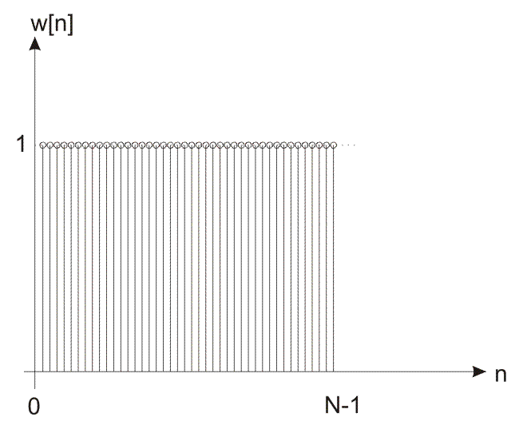 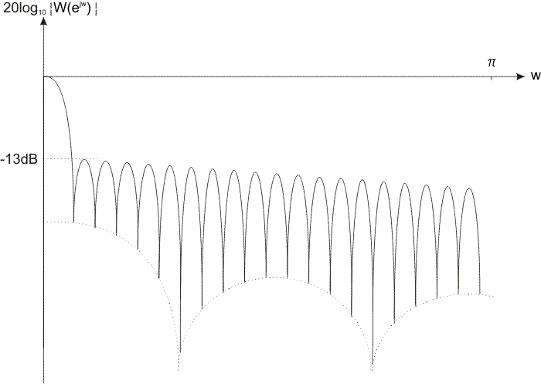

##### Figure 8. Illustrates the frequency domain of rectangular window

For its less stopband attenuation, the rectangular window is not preferable for digital filter design. Such a less attenuation is a result of cut-off samples within a window (a sequence of sampled frequencies). Up to a zero sample (from which sampling starts), all sampled frequencies are equal to zero.

#### Triangular (Bartlett) window

The triangular (Bartlett) window is one among many functions that lessens the effects of final samples. Due to it, the stopband attenuation of this window is higher than that of the rectangular window, whereas the selectivity is less.

This function also represents a kind of compromise between requirements for as narrow transition region as possible and as higher stopband attenuation as possible, where the transition region is considered more important characteristic.

One of the advantages of designing filter using the triangular window is the simplicity of computing coefficients.

The triangular window coefficients can be expressed as:

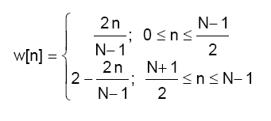

##### Figure 10. Triangular (Bartlett) window in the frequency domain (spectrum)

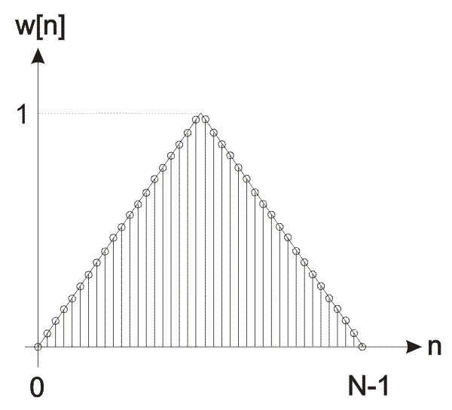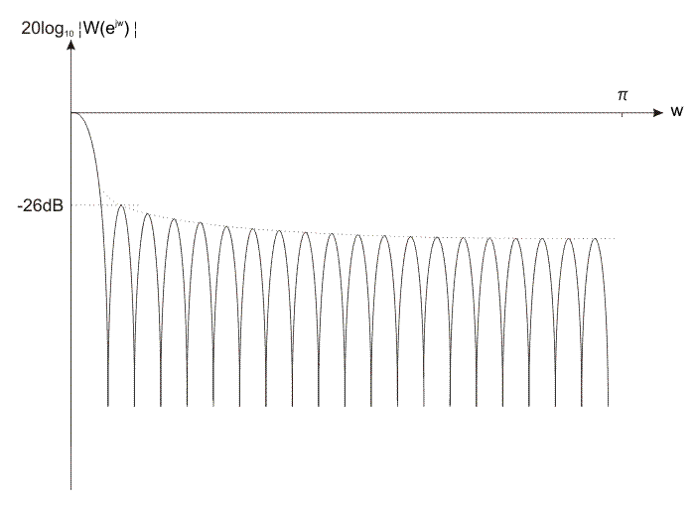

##### Figure 9. Triangular window coefficients in the time-domain

In some cases, when high attenuations are not needed, this filter can be used because it provides an easy way of computing coefficients.

#### Hann Window

The Hann window is used to lessen bad effects on frequency characteristic produced by the final samples of a signal being filtered. Digital filters designed with this window have higher stopband attenuation than those designed with triangle function. The first side lobe in the frequency domain of this filter has 31dB attenuation, whereas it amounts to 44dB in the designed filter. The transition region is the same as for triangular window, which makes this function one of the most desirable for designing.

Another advantage of this window is the ability to realtively fast increase the stopband attenuation of the following lobes. Already the second lobe has 41dB attenuation, whereas it amounts to 54dB for the designed filter.

The Hann window coefficients can be expressed as:

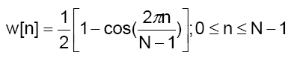

##### Figure 11. The Hann window coefficients in the time domain

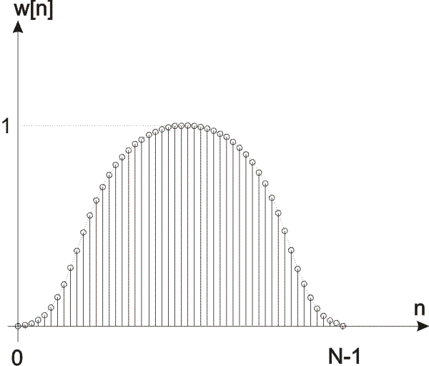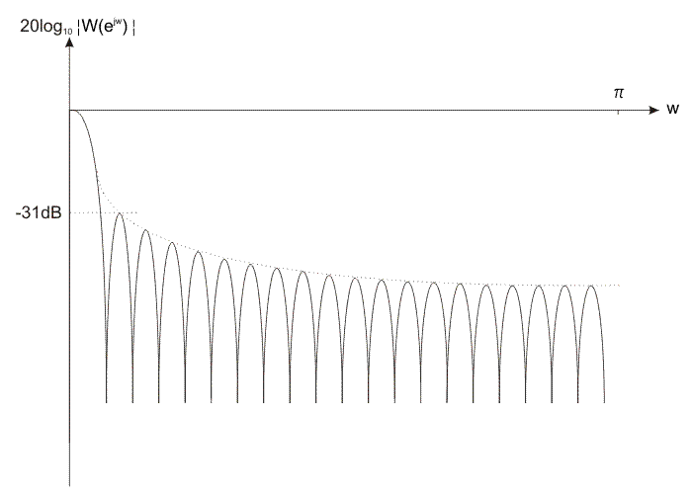

##### Figure 12. The Hann window coefficients in the frequency domain

For the same requirements for minimum attenuation, the Hann window will have a narrower transition region.

#### Hamming Window

The Hamming window is one of the most popular and most commonly used windows. A filter designed with the Hamming window has minimum stopband attenuation of 53dB, which is sufficient for most implementations of digital filters. The transition region is somewhat wider than that of the Hann and Bartlett-Hanning windows, whereas the stopband attenuation is considerably higher. Unlike minimum stopband attenuation, the transition region can be changed by changing the filter order. The transition region narrows, whereas the minimum stopband attenuation remains unchanged as the filter order increases.

The Hamming window coefficients are expressed as:

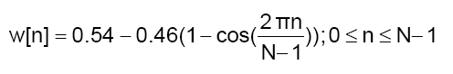

##### Figure 13. The Hamming window coefficients in the time domain

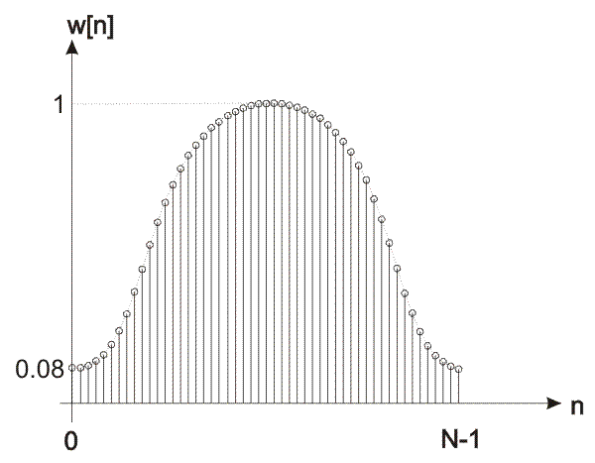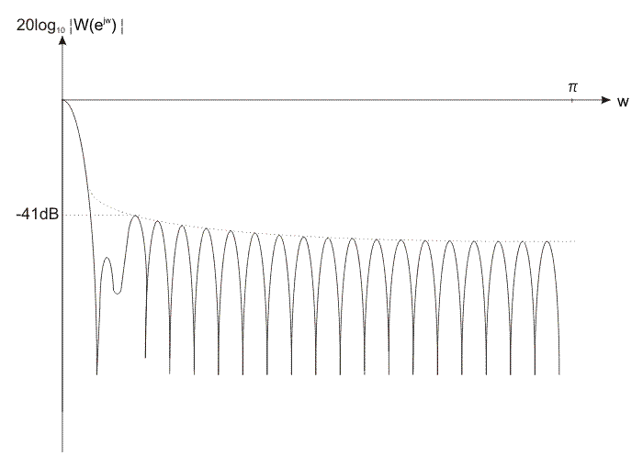

##### Figure 14. The Hamming window coefficients in the frequency domain

#### Blackman Window

The Blackman window is, along with Kaiser, Hamming and Blackman-Harris windows, considered most commonly used and the most popular windows. Relatively high attenuation makes this window very convenient for almost all applications. The minimum stopband attenuation of a filter designed with this window amounts to 75dB.

The Blackman window coefficients are expressed as:

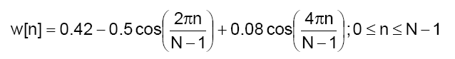

##### Figure 15. The Blackman window coefficients in the time domain

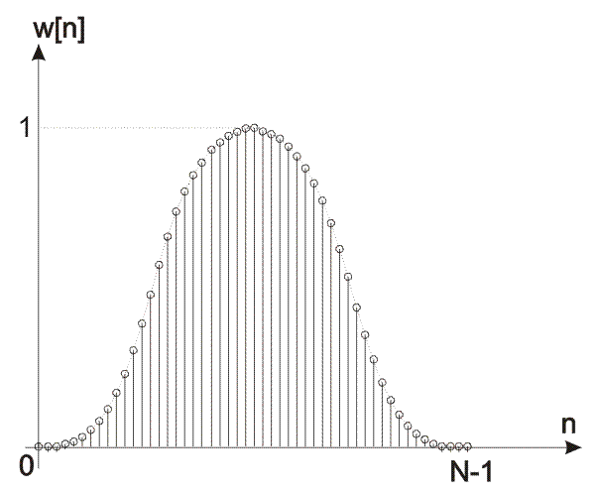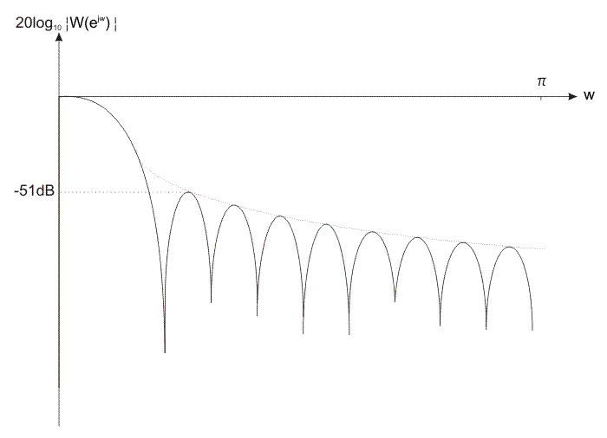

##### Figure 16. The Blackman window coefficients in the frequency domain

## Infinite Impulse Response (IIR) Filters

The IIR filter design using bilinear transformation can be split into several steps:

1. Defining filter specification;
2. Specifying analog prototype filter;
3. Computing the filter order required for a given set of specifications and specified analog prototype filter;
4. Computing the transfer function of reference analog prototype filter;
5. Conversion into analog filter via scaling;
6. Conversion into digital filter via bilinear transformation; and
7. If the obtained filter doesn’t satisfy the given specifications or if it is possible to decrease the filter order, then it is necessary to do it. The filter order can be increased or decreased according to needs and after that steps 4, 5 and 6 are repeated as many times as needed.

The final objective of defining IIR filter specifications is to find the desirable normalized cutoff frequencies (ωc, ωc1, ωc2), transition width, maximum passband attenuation and minimum stopband attenuation. The type of analog prototype filter as well as the filter order will be specified according to these parameters.

It is necessary to specify or compute the filter order required for a given set of specifications. The initial value of the filter order is roughly estimated and is changed after that depending on the obtained characteristics and requirements.

When both type and order of analog prototype filter are known, it is possible to find its transfer function. The transfer function of analog prototype filter depends on frequencies which are not scaled into the desirable range. For this reason, it is necessary to perform scaling of the transfer function so that cut-off frequencies go into the desirable range. This operation is actually conversion of reference analog prototype filter into analog filter with desirable characteristic.

Finally, the transfer function of the specified type of reference analog prototype filter is obtained by converting analog filter into digital one. This book represents the most commonly used conversion known as bilinear transformation.

### Reference Analog Prototype Filter

IIR filter design process starts with reference analog prototype filter. This includes Butterworth, Chebyshev (Chebyshev I) and inverse Chebyshev filter (Chebyshev II).

The transform function of analog filter Hsa(s) is expressed as:

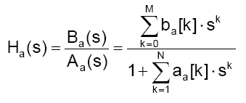

where:  
N is the filter order;  
s is the complex frequency (s = σ + jΩ); and  
M ≤ N.

In order that a system described via expression above is stable, it is necessary that all poles (the square roots of polinomial Aa(s)) are located in the left half of S plane

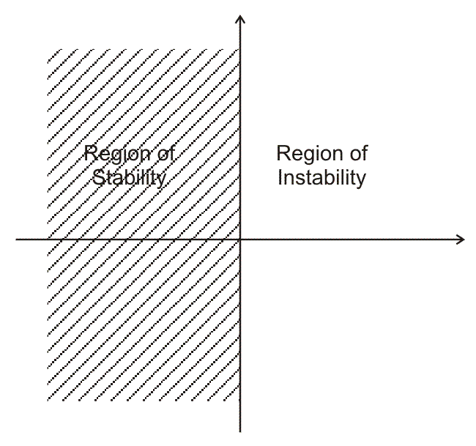

##### Figure 17. S plane and region of stability

A low-pass filter is used for analog filter design. The conversion into the appropriate type of filter (high-pass, band-pass or band-stop) is performed by converting into analog filter, i.e. frequency axis scaling.

#### Butterworth analog filter

Low-pass Butterworth analog filters are filters whose frequency response is a monotonous descending function. They are also known as „maximally flat magnitude “filters at the frequency of Ω = 0, as the first 2N - 1 derivatives of the transfer function when Ω = 0 are equal to zero.

Butterworth filter is characterized by 3dB attenuation at the frequency of Ω=1, no matter the filter order is.

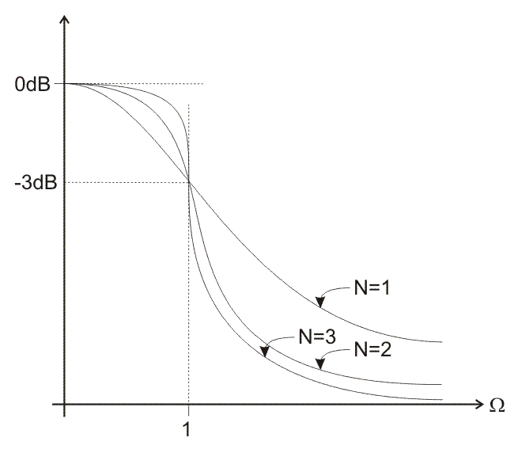

Figure 18. Frequency response of Butterworth filter

Butterworth filter is defined via expression:

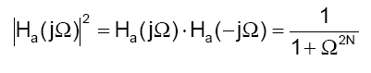

where:  
Ω is the frequency; and  
N is the filter order.

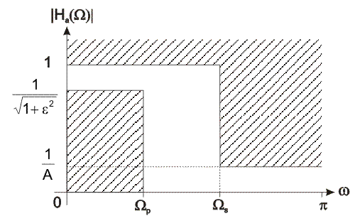

##### Figure 19. IIR filter specification

To design Butterworth reference analog prototype filter, it is necessary to know the filter order. All poles of the resulting filter must be located in the left half of the S plane, i.e. to the left of the imaginary axis.

When the filter order is known, it is easy to find its poles using expression:

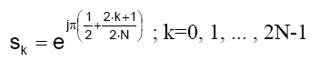

Butterworth poles are equally allocated (equidistantly) on the unit circle within the left half of the s plane. The location of poles for N=5 and N=6 is shown in Figure below.

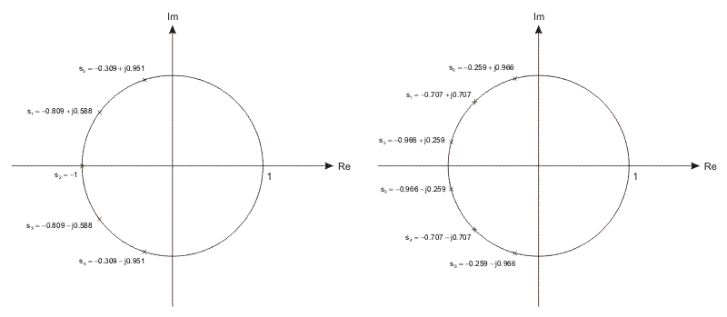

##### Figure 20. Position of Butterworth filter poles for N=5 and N=6

The transfer function of the Butterworth reference analog prototype filter is expressed as follows:

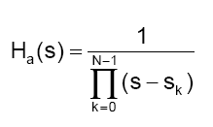

where:  
Sk is the k-th pole of the Butterworth filter transfer function  
For N=5, the transfer function is:

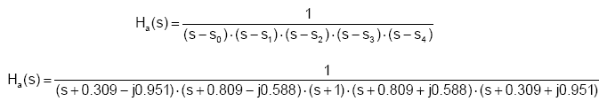

#### Chebyshev Analog Filter

Chebyshev analog low-pass filter of the first kind is a type of analog filter that has the least oscillation in frequency response in the entire passband. Therefore it is characterized by equal ripple in the passband and the stopband frequency response is monotoniously descending function.

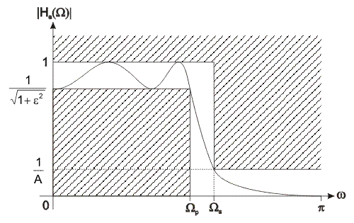

##### Figure 21. Frequency response of Chebyshev analog filter

Chebyshev analog filter is defined via expression:

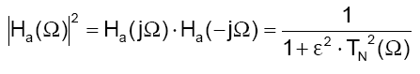

where:  
Ω is the frequency;  
N is the filter order;  
ε is a parameter used to define maximum oscillations in the passband frequency response; and  
TN is the Chebyshev polynomial.

The design process starts from the values of poles of a 1st order Chebyshev reference analog filter.

The values of poles are expressed as:

Formula 3-3-8

where:  
si is the i-th transfer function pole of analog prototype filter (complex value);  
σi is the pole; and  
Ωi is the imaginary pole.

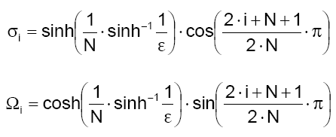

where:  
N is the filter order; and  
i=1, 2, ..., N.

The value of parameter ε is obtained via expression:

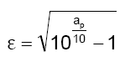

Transfer function is expressed as:

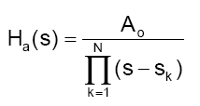

The value of A0 is found via expression:

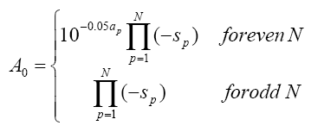

For N=5, the transfer function is:

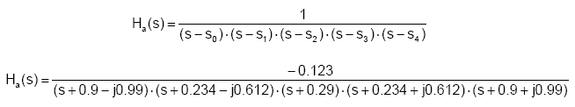

#### Inverse Chebyshev Analog Filter

Inverse Chebyshev analog filter is also known as Chebyshev analog filter of the second kind. The frequency response of this filter monotoniously falls in the passband and transition region. Similar to Butterworth filter, the frequency response is extremely flat function at the frequency of Ω = 0, as the first 2N - 1 derivatives of the transfer function for Ω = 0 are equal to zero. In the stopband, inverse Chebyshev filter has the least oscillation in the frequency response.

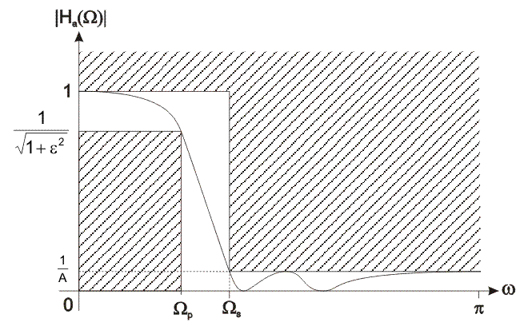

##### Figure 22. Frequency characteristic of inverse Chebyshev analog filter

To design inverse Chebyshev reference analog pototype filter, it is necessary to know the filter order.  
Inverse Chebyshev analog filter is defined via expression:

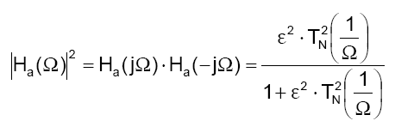

where: Ω is the frequency;  
N is the filter order;  
ε is the parameter of maximum oscillation in the passband frequency response; and  
TN is the Chebyshev polynomial.

The poles of the transfer function of inverse Chebyshev analog filter are considered reciprocal poles of the transfer function of a 1st order Chebyshev analog filter. expressed as:

Formula 3-3-16

where:  
si is the i-th pole of the transfer function of analog prototype filter (complex value);  
σi is the real pole; and  
Ωi is the imaginary pole.

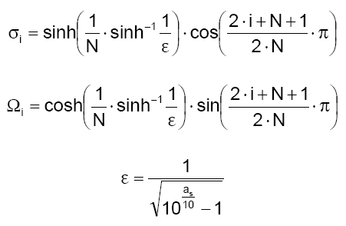

where:  
N is the filter order; and  
i=1, 2, ..., N.

The poles of the transfer function of inverse Chebyshev analog filter are found via expression:

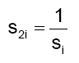

where:  
si is the pole of the transfer function of a 1st order Chebyshev analog filter; and  
s2i is the pole of the transfer function of inverse Chebyshev analog filter.

Transfer function is expressed as:

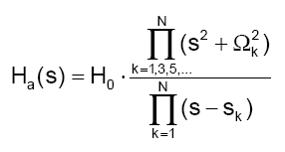

The coefficient **k** in numerator can be only an odd number. Table 3-3-1 provides a few examples of values of **k**.

|  |  |  |  |
| --- | --- | --- | --- |
| **N** | **min** | **max** | **values** |
| 5 | 1 | 5 | 1, 3, 5 |
| 6 | 1 | 5 | 1, 3, 5 |
| 7 | 1 | 7 | 1, 3, 5, 7 |
| 8 | 1 | 7 | 1, 3, 5, 7 |

##### Table 2. coefficient k in the transfer function numerator

The values Ωk are found via expression:

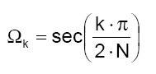

The value H0 is found via expression:

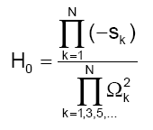

For N=5, the transfer function is:

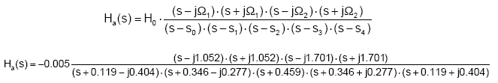

# Conclusion

Compared to IIR filters, FIR filters offer the following advantages:

* They can easily be designed to be "linear phase" (and usually are). Put simply, linear-phase filters delay the input signal but don’t distort its phase.
* They are simple to implement. On most DSP microprocessors, the FIR calculation can be done by looping a single instruction.
* They are suited to multi-rate applications. By multi-rate, we mean either "decimation" (reducing the sampling rate), "interpolation" (increasing the sampling rate), or both. Whether decimating or interpolating, the use of FIR filters allows some of the calculations to be omitted, thus providing an important computational efficiency. In contrast, if IIR filters are used, each output must be individually calculated, even if it that output will discarded (so the feedback will be incorporated into the filter).
* They have desirable numeric properties. In practice, all DSP filters must be implemented using finite-precision arithmetic, that is, a limited number of bits. The use of finite-precision arithmetic in IIR filters can cause significant problems due to the use of feedback, but FIR filters without feedback can usually be implemented using fewer bits, and the designer has fewer practical problems to solve related to non-ideal arithmetic.
* They can be implemented using fractional arithmetic. Unlike IIR filters, it is always possible to implement a FIR filter using coefficients with magnitude of less than 1.0. (The overall gain of the FIR filter can be adjusted at its output, if desired.) This is an important consideration when using fixed-point DSP's, because it makes the implementation much simpler.

FIR filters are more powerful than IIR filters, but also require more processing power and more work to setup the filters. They are also less easy to change "on the fly" as you can by tweaking (say) the frequency setting of a parametric (IIR) filter. However, their greater power means more flexibility and ability to finely adjust the response of your active loudspeaker.

# REFERENCES

# 

* 1.7.3_iir_filter_design
* Filter Specifications (Digital Filter Design Toolkit) LabVIEW 2013 Digital Filter Design Toolkit Help. June 2013
* 6.341: Discrete-Time Signal Processing Open Course Ware 2006
* <http://www.dspguru.com>
* MicroElektronica. Digital Filter Designing